Interiors

Emil Robinson
April 19 – June 1, 2024

Abattoir is pleased to introduce new paintings by Cincinnati-based artist Emil Robinson in a solo exhibition of interiors. The work stems from conversations about the history of interior paintings which serve as both records of domestic spaces as well as vessels for psychological profiles. Robinson, a classically-trained painter from Ohio, spent the past year studying local spaces, ranging from abandoned university buildings to the personal spaces of home and studio. With this show, the artist has focused his virtuoso brushwork onto smaller scale compositions in order to capture the essence of place.

Robinson has exhibited in institutions and galleries throughout the Midwest as well as in San Francisco, New York, and London. He is the recipient of grants from the Elizabeth Greenshields Foundation and the Ohio Arts Council, among others.

Interior spaces invite a range of associations. Their open spaces welcome reflection and their spatial interludes are indicative of the various thresholds we encounter throughout our lives. The function and formal simplicity of the built environment is synonymous with psychological complexity in my paintings. I want the viewer to recognize my subjects while simultaneously losing a grip on the comfort of utility which rooms doors and all other functional spaces invite.

- Emil Robinson

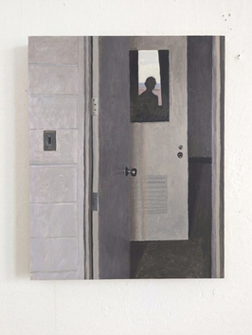 | Emil Robinson  Interior with Self-Portrait, 2024  Oil on wood panel  20 x 16 inches
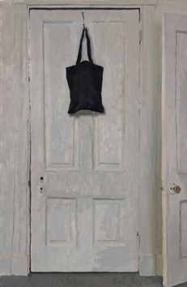 | Emil Robinson  Untitled, 2024  Oil on wood  22.5 x 14.5 inches
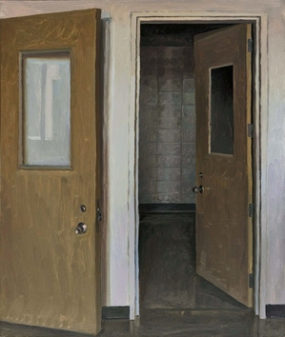 | Emil Robinson  Untitled, 2024  Oil on wood  24 x 20 inches
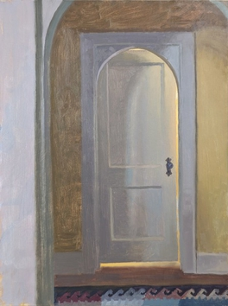 | Emil Robinson  Untitled Interior, 2024  Oil on illustration board on panel  20 x 15 inches
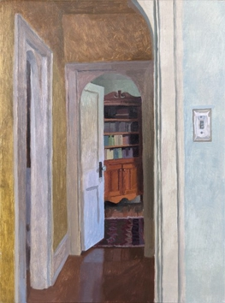 | Emil Robinson  Untitled Interior, 2024  Oil on illustration board on panel  18.5 x 14 inches
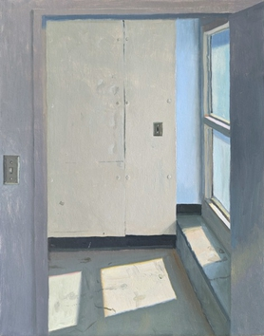 | Emil Robinson  Untitled Interior, 2024  Oil on illustration board on panel  19 x 15 inches
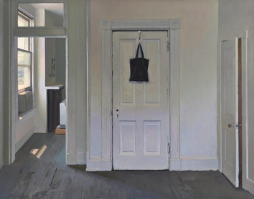 | Emil Robinson  Untitled Interior, 2024  Oil on illustration board on panel  18.5 x 23.5 inches
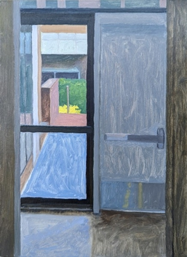 | Emil Robinson  Untitled Interior, 2024  Oil on illustration board on panel  20 x 15 inches
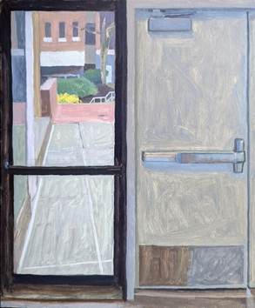 | Emil Robinson  Untitled Interior, 2024  Oil on illustration board on panel  18 x 15 inches
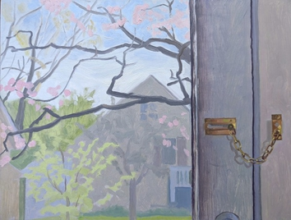 | Emil Robinson  Untitled Interior, 2024  Oil on illustration board on panel  14 x 18.5 inches
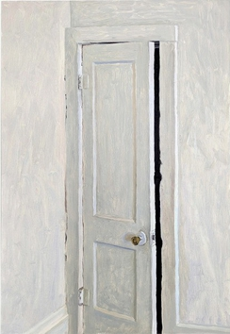 | Emil Robinson  Untitled Interior, 2024  Oil on panel  23 x 16 inches
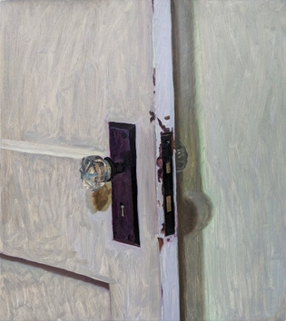 | Emil Robinson  Untitled Interior, 2024  Oil on panel  20 x 18 inches
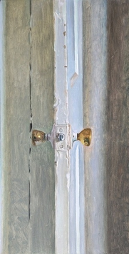 | Emil Robinson  Untitled Interior, 2024  Oil on panel  28 x 14 inches
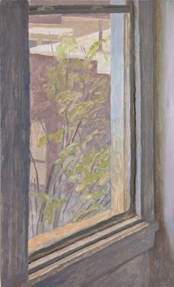 | Emil Robinson  Untitled Interior, 2024  Oil on panel  23 x 14 inches
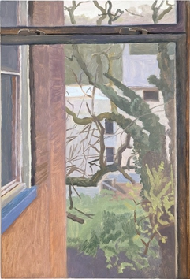 | Emil Robinson  Untitled Interior, 2024  Oil on panel  23 x 14 inches
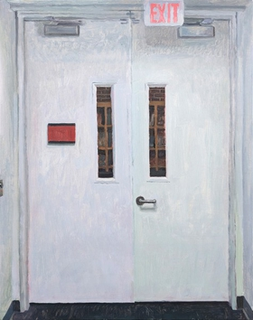 | Emil Robinson  Untitled Interior, 2024  Oil on panel  20 x 16 inches
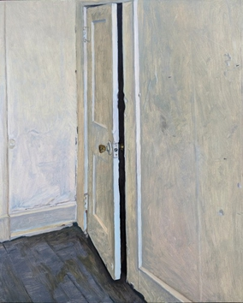 | Emil Robinson  Untitled Interior, 2024  Oil on panel  30 x 24 inches

